




HALLOWEEN Parade News:
Students are encouraged to come dressed in costume on Friday. Students can bring a mask or wig and put that on later. Halloween parade will be @1:00pm, with doors opening to parents at 12:30pm.

Fundraiser News:
Fundraiser Pickup-
Tuesday, November 5 from 1:30-4:00pm in the cafeteria.
Students with smaller orders can bring them home on the bus or car pickup. Larger orders must be picked up! Please contact me if you are unable to pick up during this time. Thanks so much for all your support of Bremen Elementary- We appreciate ALL of our
Parents/families/guardians!

Fundraiser Money Due: Wednesday November 13

Wende Vincent
525-6686 ext. 130
wende.vincent@muhlenberg.kyschools.us

Veterans Day Assembly

Monday ~ November 11 ~ 1:30pm


November Theme Days:

November 2013 Theme Days:
November 1 ~ Mustache Day
November 8~ Red/White/Blue
November 15 ~ Cowboy Day
November 22~ Camouflage Day

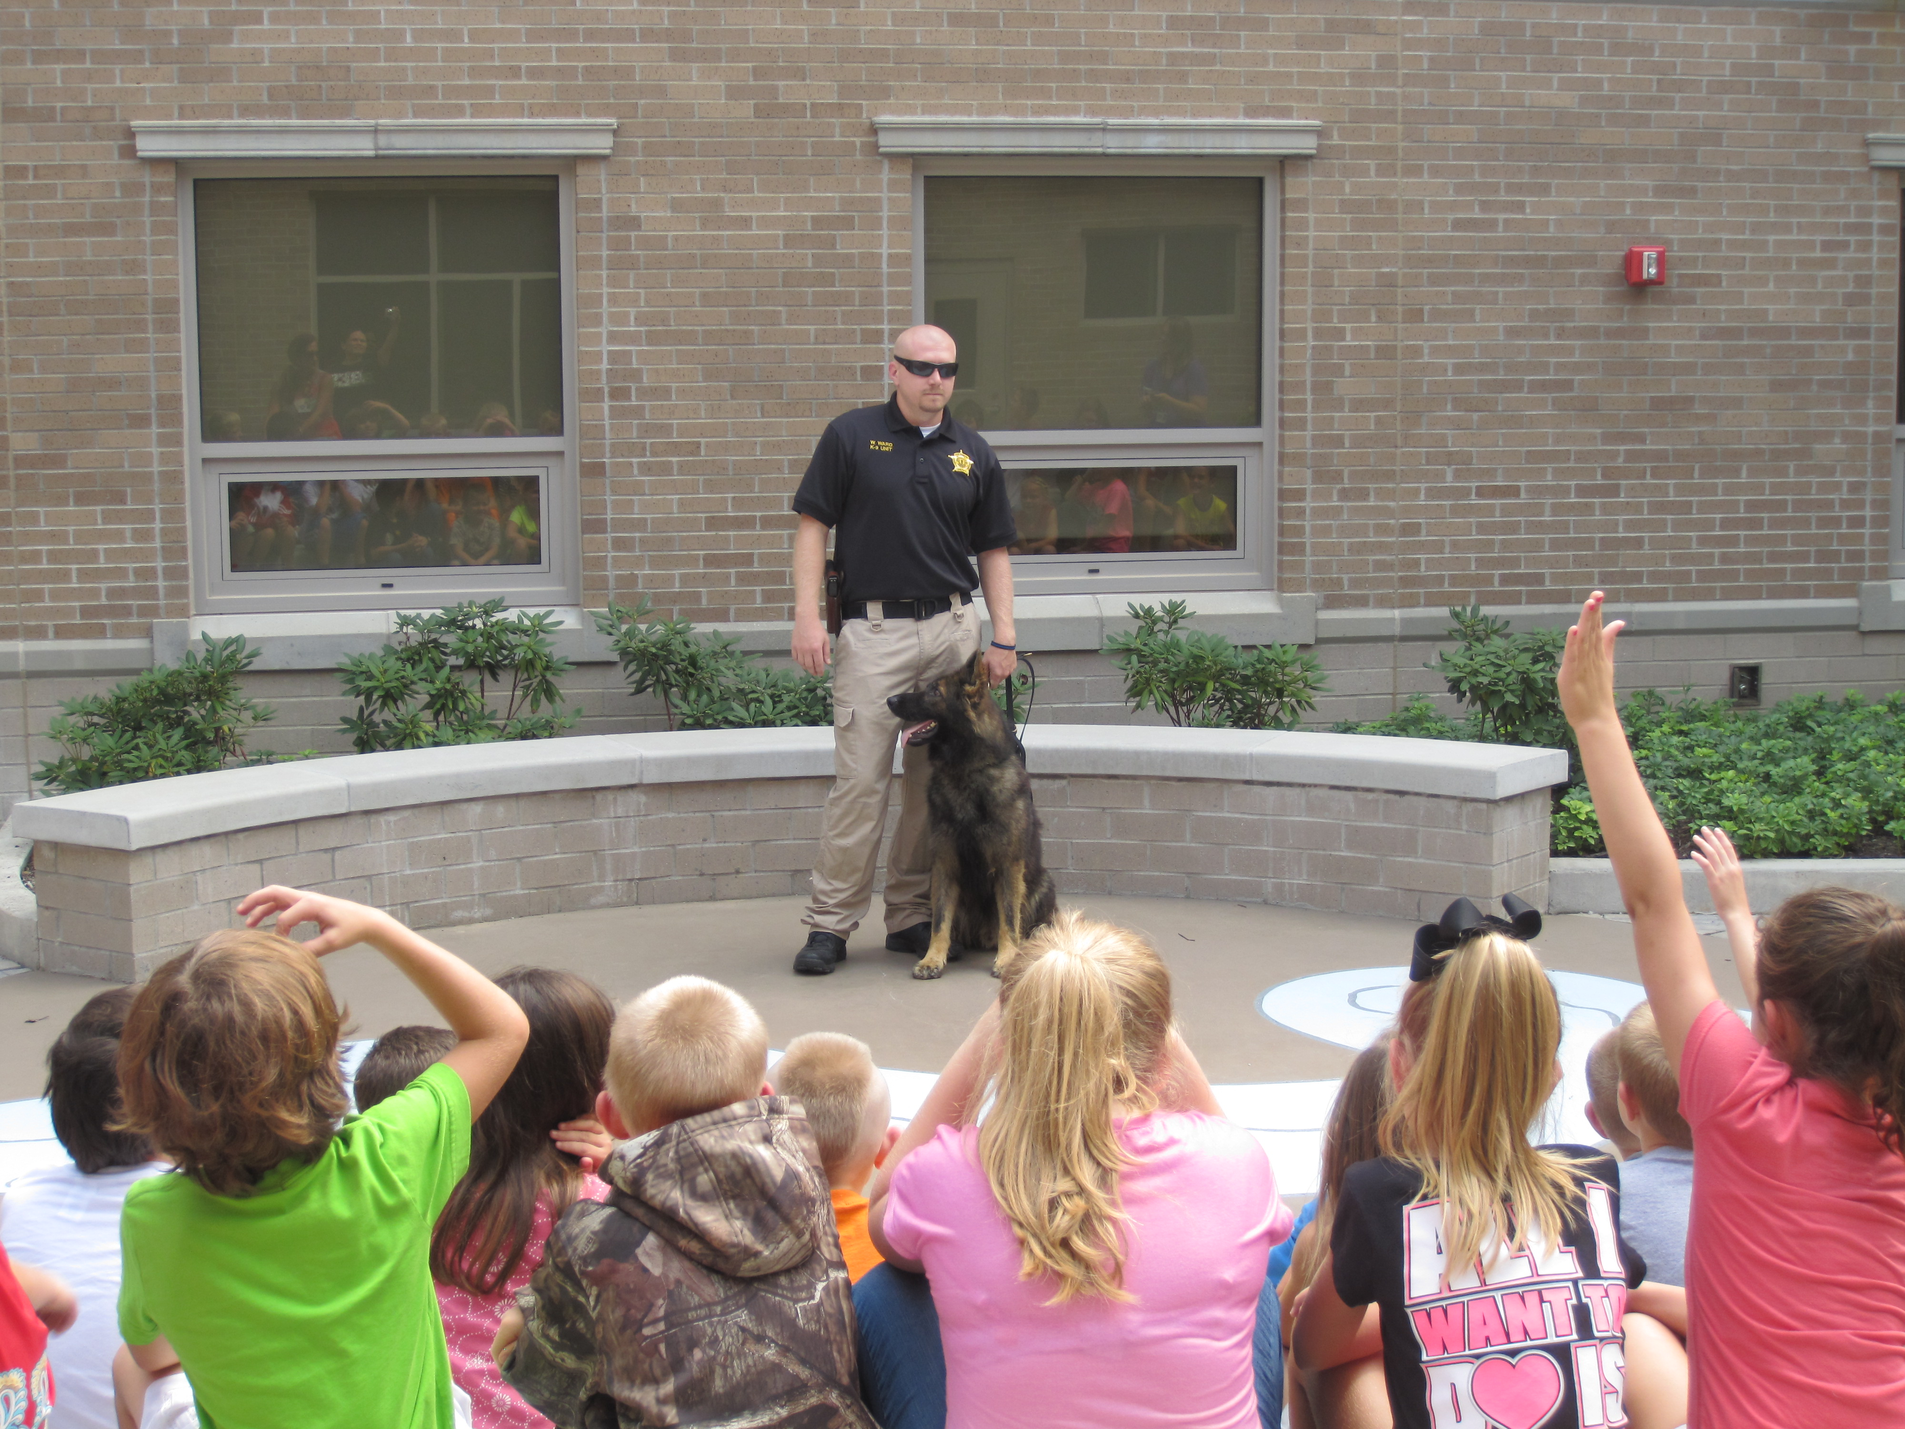
The Muhlenberg County Sherriff’s Canine Unit with the 3rd grade classes.

Bremen Elementary

http://bremenelementary.weebly.com/

