Bremen Elementary
Kindergarten Supply List
2018-2019

1 backpack (No Rollers)
1 pencil pouch/box

*All other supplies have been provided by Bremen Elementary’s PTO!

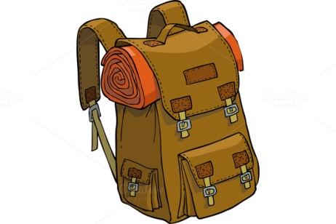
Teacher’s Wish List…
- Wet Wipes
- Big Pink Erasers
- Large Wiggle Eyes
- Dry-Erase Markers
- Cotton Balls

